**CONTENTS**

1.Introduction 3

1.1 Background 3

1.2 Restatement of the Problem 3

1.3 Literature Review 4

2.Assumptions and Justifications 5

3. Dynamic Analysis 6

3.1 Symbols 6

3.2 Force Analysis 6

4. Locations of the Containers 8

4.1 Symbols 8

4.2 Coordinate Transformation 9

4.3 Ascertainment of the Positions 10

5. Research On the DroneGo Fleets 12

5.1 Constitution of the Fleets 12

5.1.1 Types of the Drones 12

5.1.2 Amount of the Drones 13

5.2 Configurations of the Cargo Bays 13

5.3 Deliver and Video Reconnaissance System 13

5.3.1 Daily Medical Supply Deliver Plans 13

5.3.2 The Video Reconnaissance System 13

6. Configurations of the Containers 13

6.1 Explanations 13

6.2 Loading Strategies 13

7. Tradeoffs and Solutions 13

7.1 The Setbacks We Meet 13

7.2 Related Solutions 13

Sensitivity Analysis 14

Conclusions 14

Strength 14

Weakness 14

Model Extension 14

Future Work 14

Memo 14

References 15

Appendix 15

1.Introduction

1.1 Background

The hurricane hit Puerto Rico in 2017 caused terribly huge damages to local people, both materially and spiritually. According to statistics, over 2900 people died of this disaster and numerous buildings and infrastructure were destroyed. The fierce wind and rain following the hurricane have put about 3.4 million people into a situation with no power. Goods necessary for living were in short, leaving people with hopelessness and frustration. The communication and transportation systems of Puerto Rico nearly broke down, which made it extremely hard to provide ground assistance and lifesaving supplies.

Due to the awful weather and road conditions, it is impossible for the ground rescuers to get into the disaster areas. Fortunately, drone, a new type of facilities, brings a brand-new resolution to this problem. With its stability and flexibility, it could get close to people stranded by the terrible weather. What’s more, the monitoring equipment on it will help to get the present transportation situation and collect related data, which is beneficial for designing plans of rescue. To make the best of drones and build an effective system for rescuing, we have a further exploration.

1.2 Restatement of the Problem

To deliver medical supplies for people suffering from hurricane and provide video reconnaissance of the disaster areas, we are required to build a transportable disaster response system called “DroneGo”. The Questions are as follows:

1. Identify packing configurations for the cargo containers.

2. Identify the best location or locations which will enable the drone fleet to transport the medical supplies and offer the video assistance of the road networks.

3. Identify the configurations, delivery routes and schedule of the drones which could meet Puerto Rico’s medical needs

4. Identify a flight plan to get the situations of the major highways and roads through the video equipment of the drones.

5. Write a memo to introduce our modeling results, conclusions, and recommendations to the CEO of HELP, In.

1.3 Literature Review

The strengths and potentials of drones in rescuing have aroused numerous researcher’s interest. Over the years, related researches have made great progress. The strengths of drones were elaborately summarized by Yang [1]. According to his induction, drones have the characteristics of lightness, sensitivity and stability. The endurance of battery and the low cost make them more competitive in transportation and rescuing. Besides, Yang’s paper shows that drones may make breakthrough in the cross-integration of advanced technologies such as stability control, remote monitoring, vital signs monitoring, injury identification and life support.

As for the transportation planning of disaster reaction, Zheng [2] came up with a bilevel programming dynamic model to *maximize the time satisfaction of the delivery time of relief materials in the upper 1evel and the fairness in the lower level*. Considering of the uncertainty of the demand of medicine and food, Tian [3] employed Triangular Fuzzy Numbers in Fuzzy Mathematics to deal with the fuzziness. Moreover, Zhu[4] used ant colony algorithm to analyze co-optimization problem. Yu-LinShih [5] took both *emergency roadway repair and relief distribution* into consideration and build a multi -objective programming model. Manoj Vanajakumari[6] divided the process of rescuing into three parts: before the disaster, during the disaster and after the disaster. Then the author used an integrated logistic model to analyze the optimal route and configuration.

However, the research of multi-task disaster reaction planning is still at an initial stage. What’s more, the combination of configuration and transportation planning is also under exploration. Though a lot of achievements have been made, we still have a long way to go. In this paper, we propose a brand-new method to balance the medical supply delivering and the video assistance tasks. Then we employ a loading software to determine the packing configuration in the containers and the cargo bays.

2.Assumptions and Justifications

For the simplicity and convenience, we make several assumptions. The rationality of each assumption is also given.

* **Ignore the influence of air flow such as wind on the force of drones.** The force provided by the battery is much greater than that from air flow.
* **Regard the earth as a standard globe.** In many situations, for the simplicity of calculation, the shape of the earth is always simplified as a globe.
* **Assume that all the drones move at a constant speed.** As we know, it is the speed-changing process that costs much energy. To fly as far as possible, it’s wiser to move in a constant speed. Moreover, the move of drones is controlled by related electronic systems, which make it easy to achieve the goal of flying in a fixed speed.
* **Ignore the breakdown of the drones**. The drones will get an overhaul after returning to the containers otherwise the HELP, Inc may suffer from great loss. （Weather or other reasons）
* **The containers can’t be removed easily.** Because the extremely terrible weather conditions and the large amount of supplies and drones contained in them will bring great trouble to the shift, it’s more realistic to leave the containers at their initial positions.
* **The containers are tough enough to be used for a long time.** Because most of containers are made of metal, alloy or high-strength composites.
* **The bottom of the containers and the cargo bays need to be filled firstly.** In this way, the probability of collision will be lower. Otherwise the items inside may get damaged when be transported.  **(The MED cannot be covered)**

3. Dynamic Analysis

3.1 Symbols

|  |  |
| --- | --- |
| **Symbols** | **Definition** |
| W | The energy of drones’ battery |
| P | The power of drones |
| t | The maximum flying time of drones |
| F | The traction force drones get |
| v | The velocity of drones |
| T | The lift drones get |
|  | The air density |
| S | The area of the rotor |
| KT | The coefficient of the lift |
| KQ | The coefficient of the torque |
| r | The radius of the rotor |
|  | The rotational velocity |
| s | The distance drones can cover |
|  | The angular velocity of the rotors |
| G | The gross gravity of the drones |

3.2 Force Analysis

In order to analyze the regulation between the velocity of the drones and the weight of the goods they carried, we established a dynamic model. The force analysis is as follows.

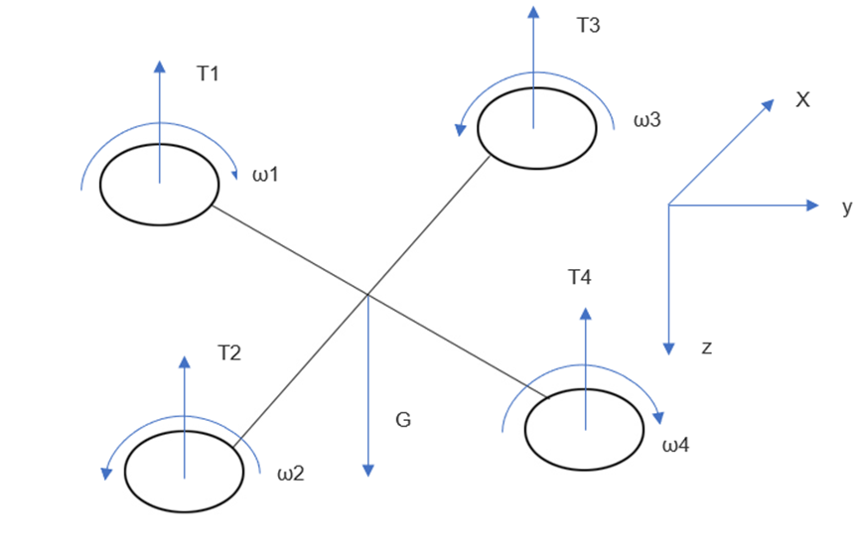

Figure 3.1 The Force Analysis of the Drones

According to Wang[7], micro air vehicles’ Reynolds number is about 20000, so the force implied on drones’ rotor is mainly viscous resistance. The viscous resistance varies directly as the velocity.

Moreover, we regard the energy of the battery as a fixed value.

 (1)

The power of the drone is the product of the traction force and the velocity.

 (2)

According to Aerodynamic Theory of rotor and blade of aircraft, when the blade rotates, lift T, resistance D, torque Q and the rolling moment L perpendicular to the plane of the wing will come into existence. All of them vary directly as the square of the rotational velocity Ω. Ignore the resistance D and the rolling moment L because their coefficient of them is nearly zero.

 (3)

 (4)

 (5)

Based on the researches above, we can draw the conclusion that the distance drones can cover obeys negative linear correlation with the total mass of the goods they carry.

Apart from the dynamic analysis, we also consider of the process that the drones lands on the ground. According to [8], the highest flying height of drones is about 400 feet and the average speed when they ascend or descend is around 5m/s. We estimate that the extra time cost during the procedure reaches at 50s. The electricity cost can’t be ignored. Based on the data about the decrease of the flying distance when carrying goods and the extra energy waste of the vertical motion, the parameter of the drones, especially the distance they can cover, should be re-considered.

All the data used in latter parts are adjusted according to this segment’s analysis.

4. Locations of the Containers

Question B require us to select the best position or positions for the containers to enable the DroneGo fleet to meet the demand of medical supplies in Puerto Rico and provide the high-resolution aerial video reconnaissance. For the simplicity, we calculate the distance between two positions from their coordinates. Because of the amount of the containers needed is unclear, for purpose of minimizing the cost, we try to use just one container firstly. However, according to the result, no matter what kind of drones we choose, the demand of medical supplies can’t be met at the same time. As a result, we decide to add more containers. Based on our analysis, two more containers are necessary. We finally decide their positions.

4.1 Symbols

|  |  |
| --- | --- |
| Symbols | Definition |
| xi | The distance between the first container to city i |
| yi | The distance between the second container to city i |
| zi | The distance between the third container to city i |
| R | The radius of the earth |
| i | The longitude angle of city i |
| i | The latitude angle of city i |
| TD | Total distance |
| **R** | The matrix of total packages requirement of two cities |
| **rij** | The total packages requirement of city i and city j |
| **D** | The matrix of the distance between two cities |
| **dij** | The distance between city i and city j |
| **R1** | The normalized **R** |
| **D1** | The normalized **D** |
| **K** | Subtract **D1** from **R1** |
| F | The objective function of the programming model |
| Xij | 0-1 variable |

4.2 Coordinate Transformation

According to our assumptions in Part 2, the earth can be regarded as a standard globe. So we can get the distance of two places through their longitude and latitude. First, transform the angle system to radian system. Here is the equation.

 (6)

Then calculate the distance through the following equation.  (7)

(C++)

4.3 Ascertainment of the Positions

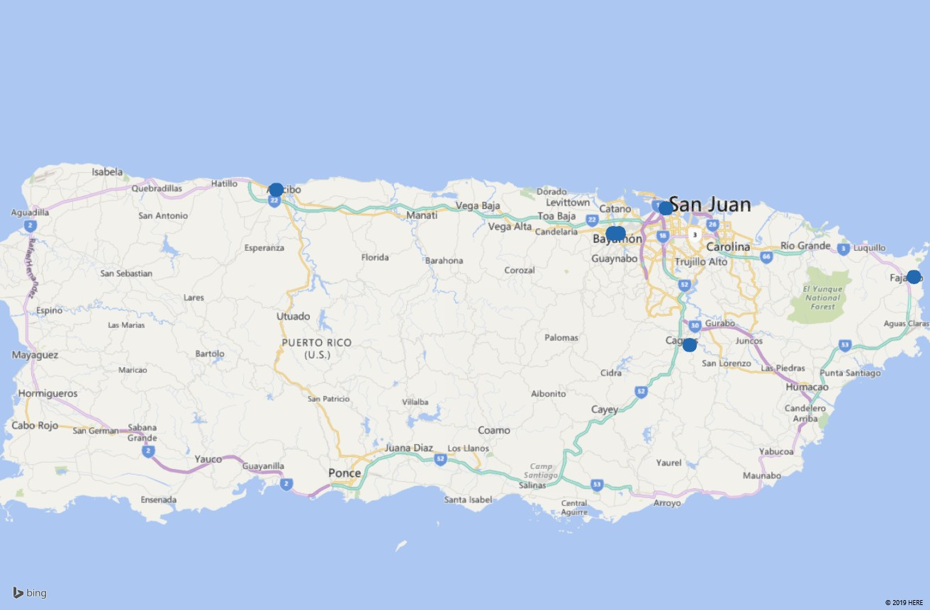By PowerMap, we determine the five cities through the coordinates provided. The relative positions are as follows.

**4.Fajado**

**1.**

**3.Caguas**

**2.Bayamón**

**5.Arecio**

Figure 4.1 Five Cities Corresponding to the Given Coordinates and Their Numbers

Firstly, we explore a situation with only one containers. As is known, the aim of after-disaster rescuing is providing adequate and timely support rather than reduce the cost as much as possible. Besides, **comparing to provide video assistance, medicine supply is much more urgent**. Life and health is the most important aspect in all conditions. To ensure the medical supply can reach at the disaster areas in time, we choose the total distance from the container to another five cities as the objective function and calcite its position through **Lingo**.

 (8)

, i=1,2,3,4,5

We get the coordinate of this place, **(18.39°N,66.15°W)**

However, no matter what kind of drones we choose, this container can’t meet Arecibo and Fajado’s demand of medicines in that case because the distance from this container to the two cities above is beyond the range of all of the drones.

Therefore, we consider placing more containers. In order to figure out the specific cities the containers support, we establish an **integrate linear programming model.** From Figure 4.1, if we take Arecibo into consideration, it’s impossible to take another city into account (at the same time). **Thus, we put a container in Arecibo** which will meet the demand of the medicines and transportation reconnaissance of local people. We set two more containers for the four cities.(According to our algorithm, if only one more container is necessary, the outcoming of our model will express this information) This time we take both of the distances and the requirements of medicines into consideration and have a normalization on them.

**R= ** (9)

**D= **  (10)

Through the built-in function of Matlab, we get their corresponding normalized matrixes R1 and D1.

**K=R1-D1=**  (11)

Here is the objective function:

max F=*K*12×X12+*K*23×X12+*K14*×X14+*K24*×X24+*K34*×X34 (12)

s.t.

With Lingo，we work out that:

X12=X23=1，X14=X24=X34=0 (13)

The result shows that **Fajado should be supported by one single container** while San Juan, Bayamón and Caguas will accept the support from the third container.

To determine the location of the third container, we employed the **Lingo** algorithm again. The objective function is as follows.

 (14)

, i=1,2,3

We find that the coordinate of the third container nearly coincides with that of Bayamón(the coordinate should be showed), so **we choose Bayamón as the location of it**. Of course, according to the same principal as the ascertainment of the first container’s position, the second container should be placed at Fajado.

In all , **the three locations of the containers are at Arecibo, Fajado and Bayamón**.

5. Research On the DroneGo Fleets

5.1 Constitution of the Fleets

Question A ask us to give a recommendation on the constitution of the DroneGo Fleets. Comparing to other drones, several types of drones given have obvious strengths. According to our judgement and the fuzzy synthetic evaluation mode we establish, we finally choose four kinds of drones. Later, we determine the amount of the drones in each fleet on the basis of the medical and video reconnaissance requirements. As for the configuration of the cargo bays, we use a loading software, Cube-IQ, to simulate the layout of the medical supplies and drones. At the end of this part, we design the routes and arrangements of these drones to accomplish their mission of delivering medicines and collecting image information of the road networks.

5.1.1 Types of the Drones

To find out the most appropriate types of drones, firstly we compare them with each other straightly to find their special characteristics. We were attracted deeply by type H, the tethered one, for the first sight. This kind of drones will act as a signal collection to gather all the traffic information from the drones sent for video reconnaissance and each container will equipped with one. Besides, we employed fuzzy synthetic evaluation model to pick up three more types of drones to offer helps about medicine delivering and video reconnaissance.

5.1.2 Amount of the Drones

(此处加入一张流程图)We divide the drones into two groups: the delivering drones and the traffic network monitoring drones. Each city’s amount of the first group drones depends on the medical packages needed and the second group’s amount depends on the amount of the roads nearby the container. We circle the farthest range of view of the drones with the longest flying distance taking off from the container. The roads in the circle should be monitored per day. Hence the amount of drones in group two is clear. Moreover, in specific situations, one drone can execute both of the two tasks if the delivering destination is on the road that needed to be monitored. In that case, a drone with enough flying distance and a video can manage it. Apart from that, one H type drone is needed at each container’s position.

5.2 Configurations of the Cargo Bays

With the help of Cube-IQ and on the basis of each drone’s destination as well as the requirement of it, the configuration of each cargo bay can be determined easily. If the city is near the container, we choose one drone of type E to deliver, such as Arecio, Bayamón and Fajado. The drone we choose is (largely) enough to carry the city’s daily requirement. As for drones which will fly to San Juan and Caguas, we choose one drone of type C separately. Because of the large volume and the video it carries, this kind of drone will finish two tasks at the same time.

5.3 Deliver and Video Reconnaissance System

Though the aim of rescuing is to offer help to people in need timely and provide adequate necessities, it is also vital to reduce the cost, especially for the NGOs. So our modelling goal is to minimize the cost on the basis of finishing all the rescuing tasks. Because it’s hard to know the cost of each drone, so we assume that the price of each drone is the same. So our goal transforms into minimizing the amount of the drones. Combining with the conclusions above, we can determine the deliver and video reconnaissance system.

5.3.1 Daily Medical Supply Deliver Plans

The contents of each drone’s cargo bay and the corresponding types of drones are clear, so the daily medical supply deliver plans are also explicit. The result is as follows.

5.3.2 The Video Reconnaissance System

To cover most of the disaster areas’ road networks, the drones are expected to fly along the roads. To get the most economic and appropriate amount of the drones, we select the type B drones to provide the video monitoring assistance from three types of moveable drones. We draw a circle in which all the possible range that the drones can see is included .When choosing the radius of the circle, we consider of the electricity cost of the vertical motion stage and leave a little energy to deal with the emergency. To conclusion, we use about 40 percent of the type B drones’ maximum flying distance as the radius. By counting the roads in the circle and combining the type B drones’ range of view, we will know the amount of the type B drones as well as their routes.

6. Configurations of the Containers

6.1 Explanations

1.For purpose of simplifying the rough three-dimensional objects loading problem, we search for related software on the Internet. We finally choose Cube-IQ to solve the problem because it provides a more intuitive loading plan and it’s much easier to cross the threshold comparing with other software.

2.To protect the drones and the medicines, we firstly fill the bottom of the container. Otherwise the collision may destroy the contents.

3.In order to provide enough supplies for the disaster areas and reduce the use of cushioning material, we decide to provide more goods than the realistic demand. However, for lowering the cost of purchasing medicines, we finally decide to provide goods to meet the demand of three months. (thicken it?)

6.2 Loading Strategies

Through the analysis above, we can determine the types and the amounts of the containers’ contents. With the help of Cube-IQ, the configuration can be worked out easily.

7. Tradeoffs and Solutions

Though we can solve most of the problems we meet, there are still several troubles we can’t get over under such conditions. In order to overcome all the difficulties and set up a perfect aerial disaster relief response system, it’s necessary to make tradeoffs.

7.1 The Setbacks We Meet

Now we can fulfill the task of delivering medical supplies well. However, limited to the amount of the containers, we are not able to get all the information of the whole road system, which means the conditions of several parts of the roads are uncertain. On the basis of our model, the southwest part of Puerto Rico remains to be supported an the traffic system there needs to be monitored.

7.2 Related Solutions

We come up with a solution to cover more road networks and deliver medical supplies for people living in the southwest part of Puerto Rico. To accomplish this goal, one more container is needed. We refer to the population density of Puerto Rico and find that it’s wiser to place the forth container in Ponce. (note it)

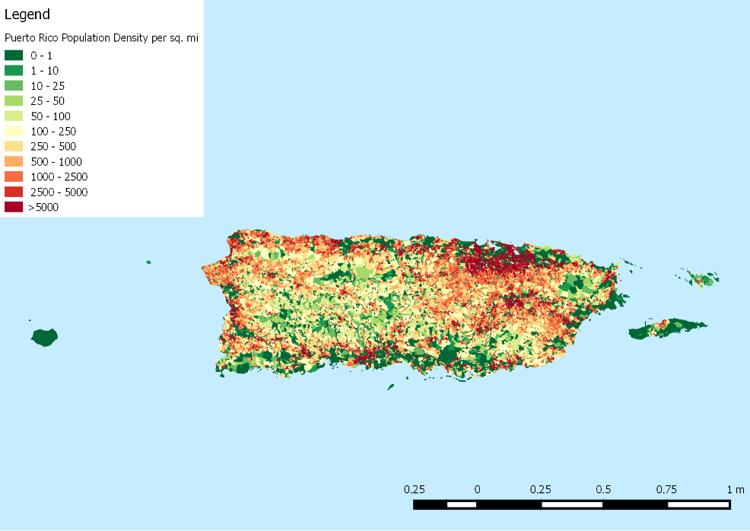Figure 7.1 The Population Density Map in Puerto Rico

Next we

8. Sensitivity Analysis

9. Conclusions

9.1 Strength

9.2Weakness

9.3Model Extension

10. Future Work

11. Memo

References

[1] Yang Yang, Luo Ting, Tang Gewei, Zhang Jiaxiong, & Wang Hefei. (2018). Research on the application of multi-rotor uav in medical rescue. Medical Equipment, 39(6).

[2] Zheng Bin, Ma Zujun, & Zhou Yufeng. (2017). A bilevel programming model for dynamic site-intermodal transport of emergency logistics after earthquake. Chinese Journal of Hospital Infection, 26(10), 326-337.

[3] Tian Jun, Ma Wenzheng, Wang Yingluo, & Wang Kanliang. (2011). Particle swarm optimization (pso) for dynamic dispatch of emergency supplies. Systems Engineering Theory and Practice, 31(5), 898-906.

[4] Zhu Li , Ding Jialan , & Ma Zheng . (2018). Collaborative optimization of heterogeneous transport under emergency conditions. Journal of Management.

[5] Yan, S. , & Shih, Y. L. . (2009). Optimal scheduling of emergency roadway repair and subsequent relief distribution. Computers and Operations Research, 36(6), 2049-2065.

[6] Vanajakumari, M. , Kumar, S. , & Gupta, S. . (2016). An integrated logistic model for predictable disasters. Production and Operations Management, 25(5), 791-811.

[7] Wang Dapeng. (2017). Analysis of Flight Dynamics Characteristics of Four-Rotor Aircraft. (Doctoral dissertation).

[8]https://www.faa.gov/news/press_releases/news_story.cfm?newsId=18295&cid=TW299

Appendix